KOPS Online Shopping Cart Application – User Documentation

**Group** **K**(*evin*) **O**(*stap*) **P**(*oulad*) **S**(*uthas*)

Contents

How to Run the Application 2

1. Open Eclipse 2

2. Import the WAR file “GroupKOPS_COMP303Assignment2.war” 2

3. Ensure that the Java version in Project Facets is set to 1.8 2

4. Run the Web Application on server. 3

5. Open a browser and navigate to http://localhost:8080/GroupKOPS_Assignment2/ 3

How to Test the Application 4

1. Click on Let’s Start Shopping to go to the Products page 4

2. Trying to buy too many items (quantity > stock) 5

3. Adding product to cart and Viewing Shopping Cart 5

# How to Run the Application

## Open Eclipse

## Import the WAR file “GroupKOPS_COMP303Assignment2.war”

## Ensure that the Java version in Project Facets is set to 1.8

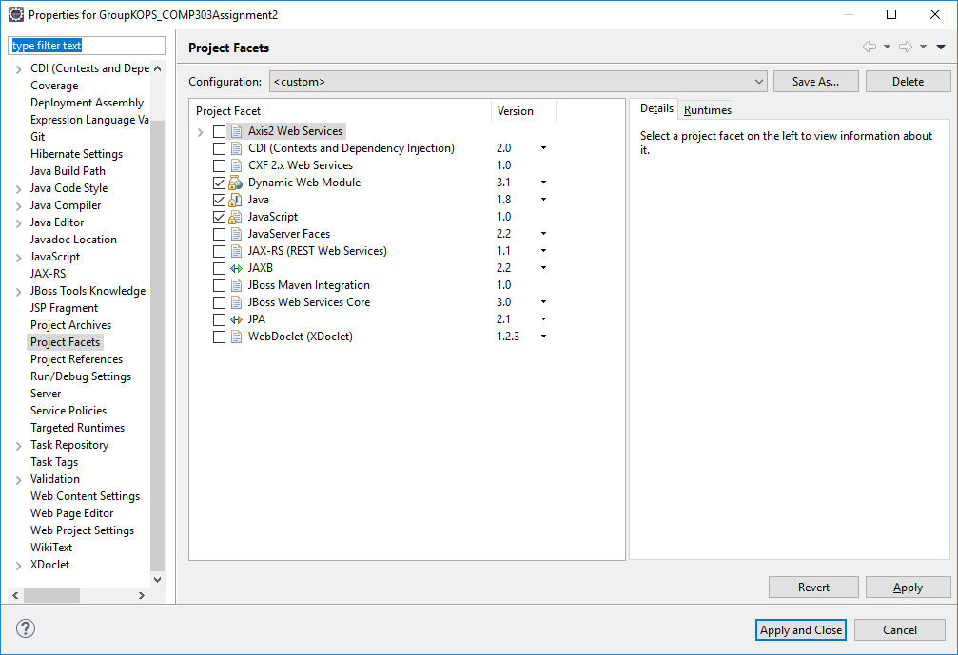

## Run the Web Application on server.

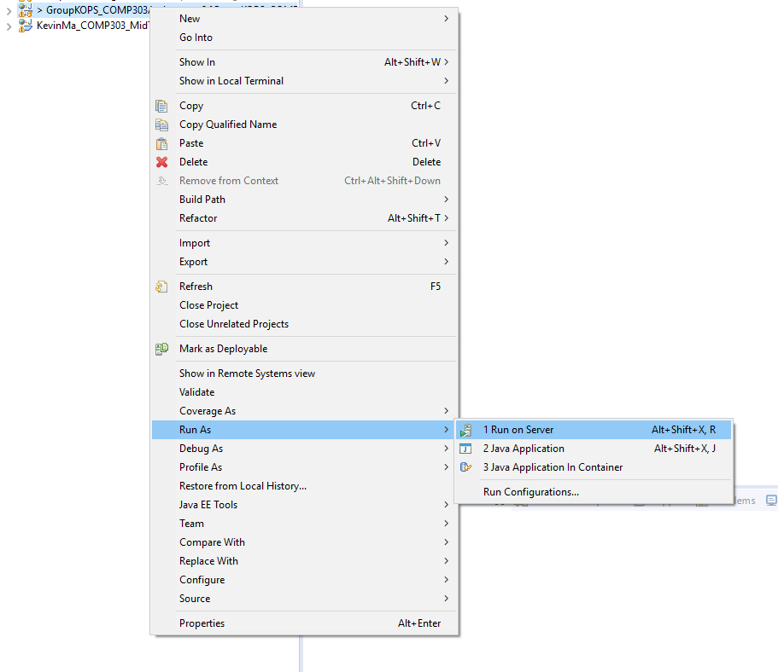

## Open a browser and navigate to <http://localhost:8080/GroupKOPS_Assignment2/>

You should now see this screen: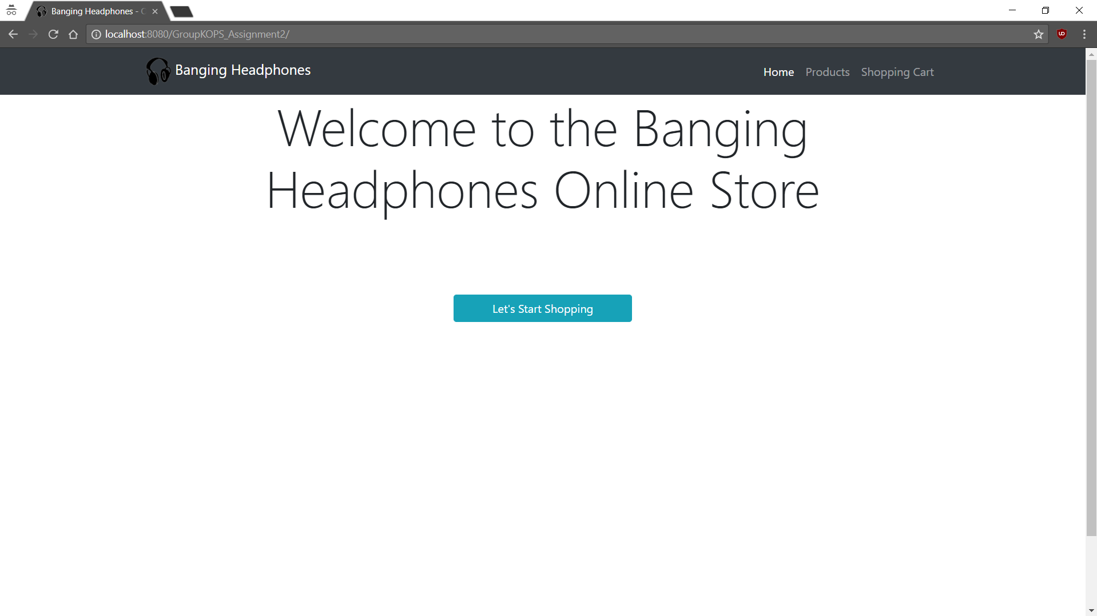

# How to Test the Application

## Click on Let’s Start Shopping to go to the Products page

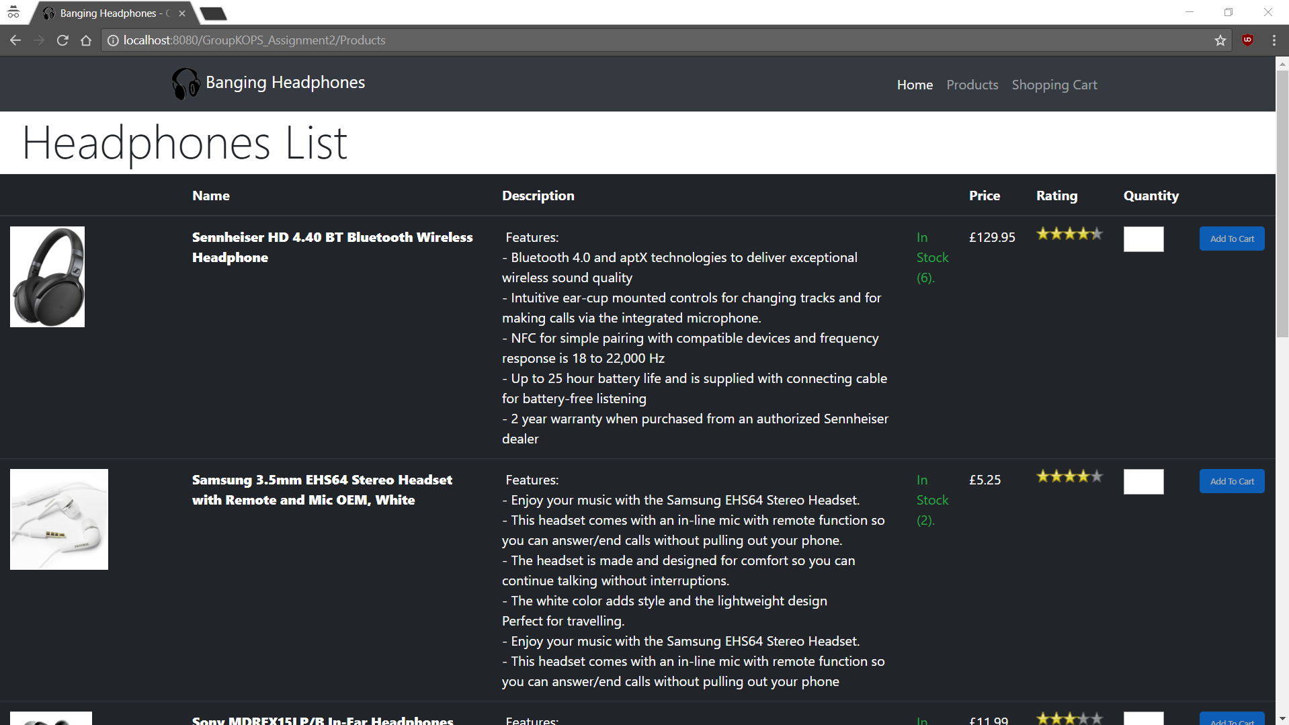

## Trying to buy too many items (quantity > stock)

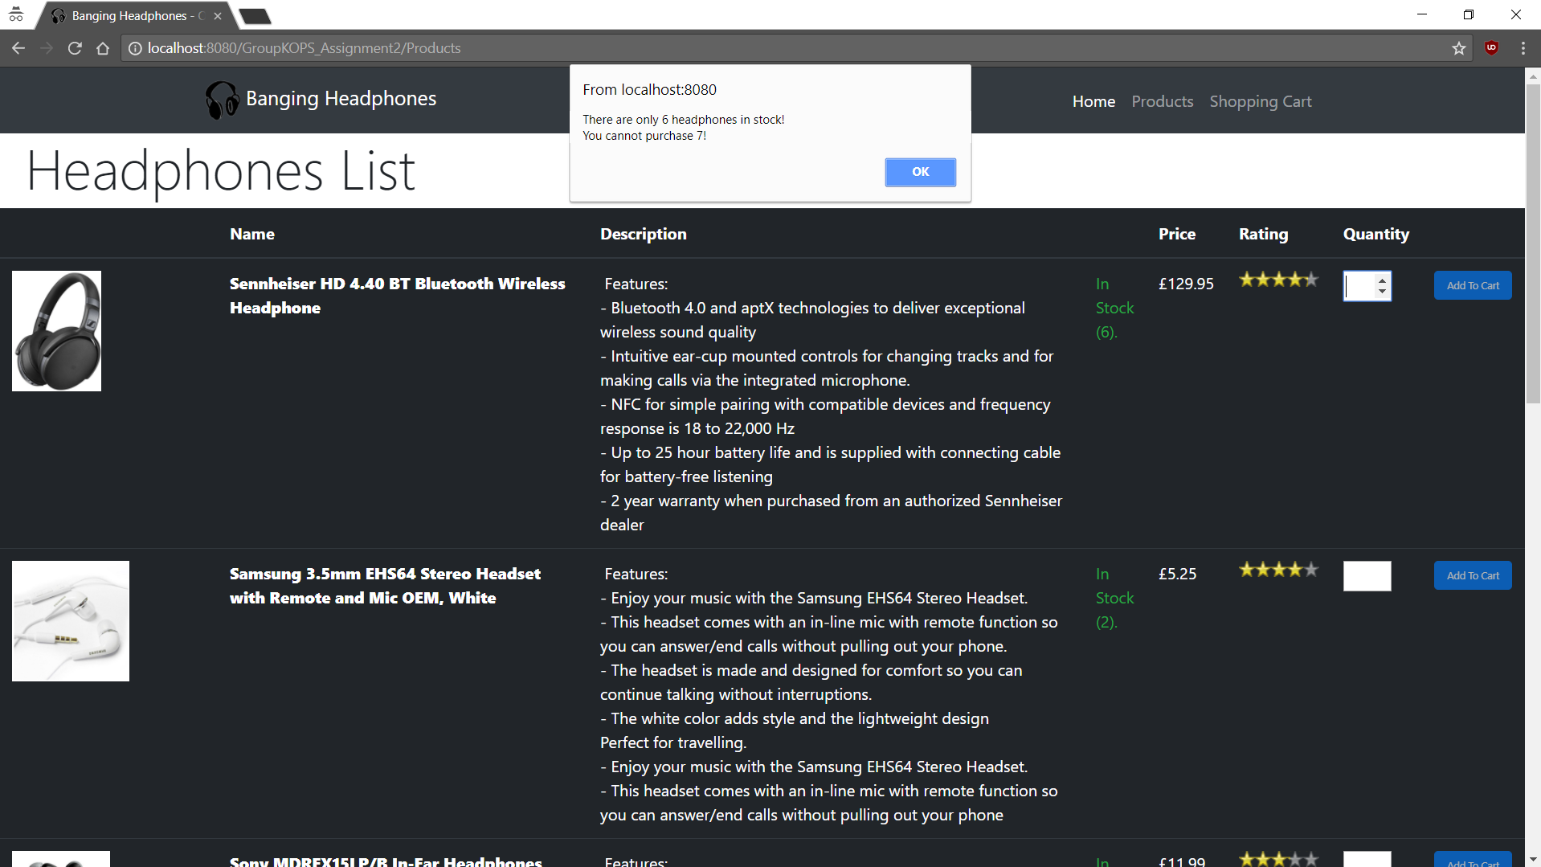

## Adding product to cart and Viewing Shopping Cart

